**Basic Models**

Sequence to sequence model

Translation:

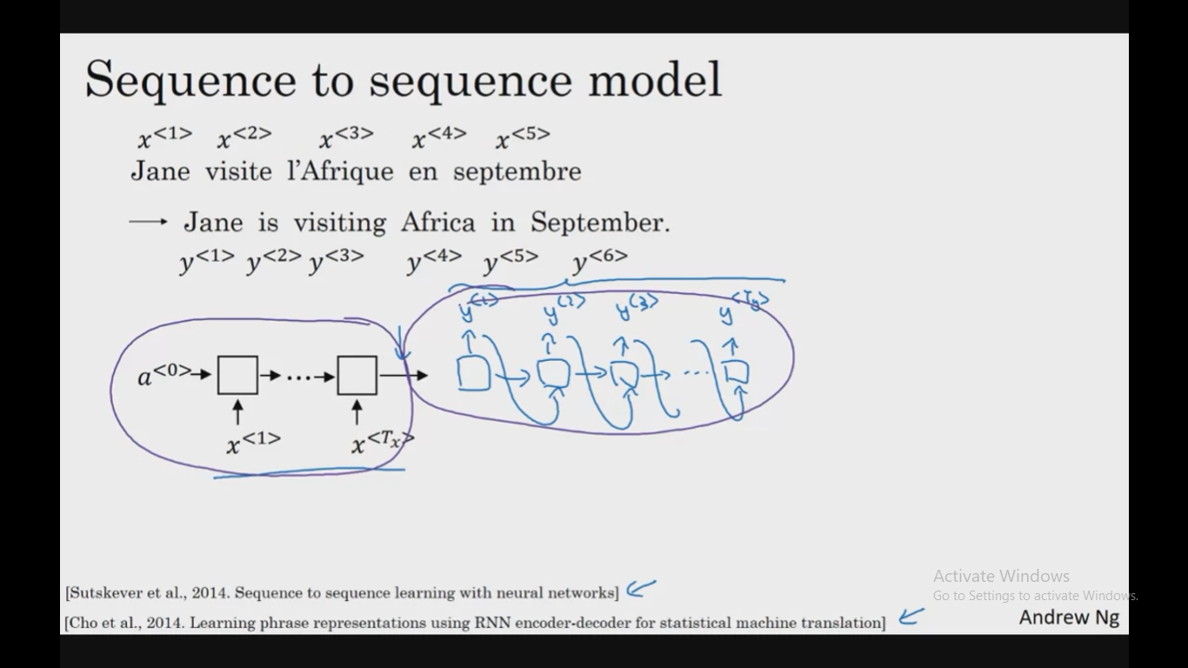

Image to text translation (Image captioning):

